ST. FRANCIS INSTITUTE OF TECHNOLOGY
Department of Information Technology

Title of Project:
Design and Development of Web Application for Project Management Process

About the Client
Mott MacDonald is a global, employee-owned management, engineering and development consultancy firm working on a range of projects in the transport, water, industry, buildings, energy, environment, health, education, communications and institutional development sectors. The International registered office is situated at Mott MacDonald House, 8-10 Sydenham Road, Croydon, Surrey CRO 2EE, United Kingdom and in India under the name Mott MacDonald Private Limited, having its registered office at 44, Dr R G Thadani Marg, Worli, Mumbai, Maharashtra, India-400018.

The scope of work included the following:-

- Design & development of web application for project management to have a dashboard with login access control for Admin, Project Principal, Project Manager and Contractor
- Design & development of front ends for Project Principal (PP)/ Project Manager (PM)/ Contractors/Site engineer to key in inputs with access control, including provision for uploading site photographs and inserting remarks by PP/PM
- Generation of Daily Progress Report (DPR); Weekly Progress Report (WPR); and Monthly Progress Report (MPR) having graphical representations
- Testing and deployment of web-application on field
- Refinement in software

The project agreement was initiated on 4th October 2018 in the presence of Principal, Dr Sincy George, Head of Department-IT, Prof (Dr.) Joanne Gomes, Associate Professor-IT , Ms. Nitika Rai, Assistant Professor-IT, Ms. Mrinmoyee Mukherjee, Business Head, Mr Ravindra Dwivedi and Divisional General Manager , Mr. Amit Mukherjee. The duration of the project was of one year and was delivered in seven phases. Each phase followed strict timeline with respect to expected outcomes.
The SFIT project development team includes-

Technical Director: Prof (Dr.) Joanne Gomes
Project Manager: Ms. Nitika Rai and Ms. Mrinmoyee Mukherjee
Technical Support Staff: Mr. Gaurav Salvi

The Mott Macdonald project development team includes-

Divisional General Manager: Mr. Amit Mukherjee
Business Head, PPCM Practice Leader: Mr. Ravindra Dwivedi
Senior Civil Engineer: Ms. Sharmila Munagavalasa

The estimated cost of the project is Rs. 6,40,000/-

Snapshots

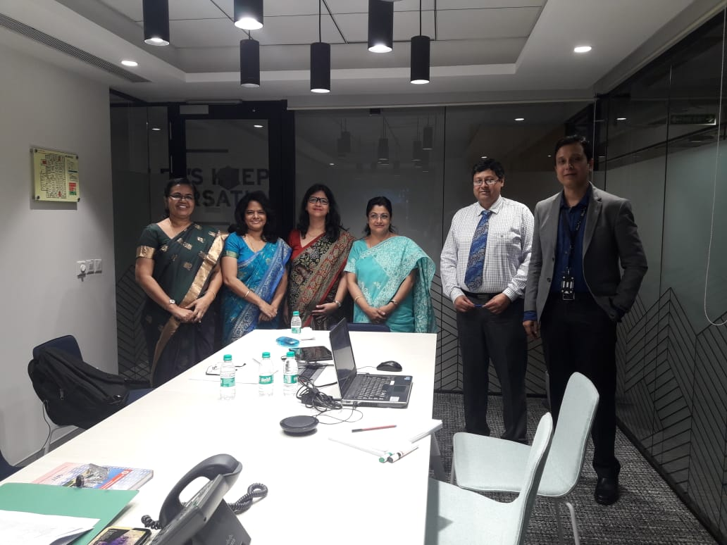
(L-R): Dr. Sincy George, Dr. Joanne Gomes, Ms. Nitika Rai, Ms. Mrinmoyee Mukherjee, Mr. Amit Mukherjee, Mr. Ravindra Dwivedi

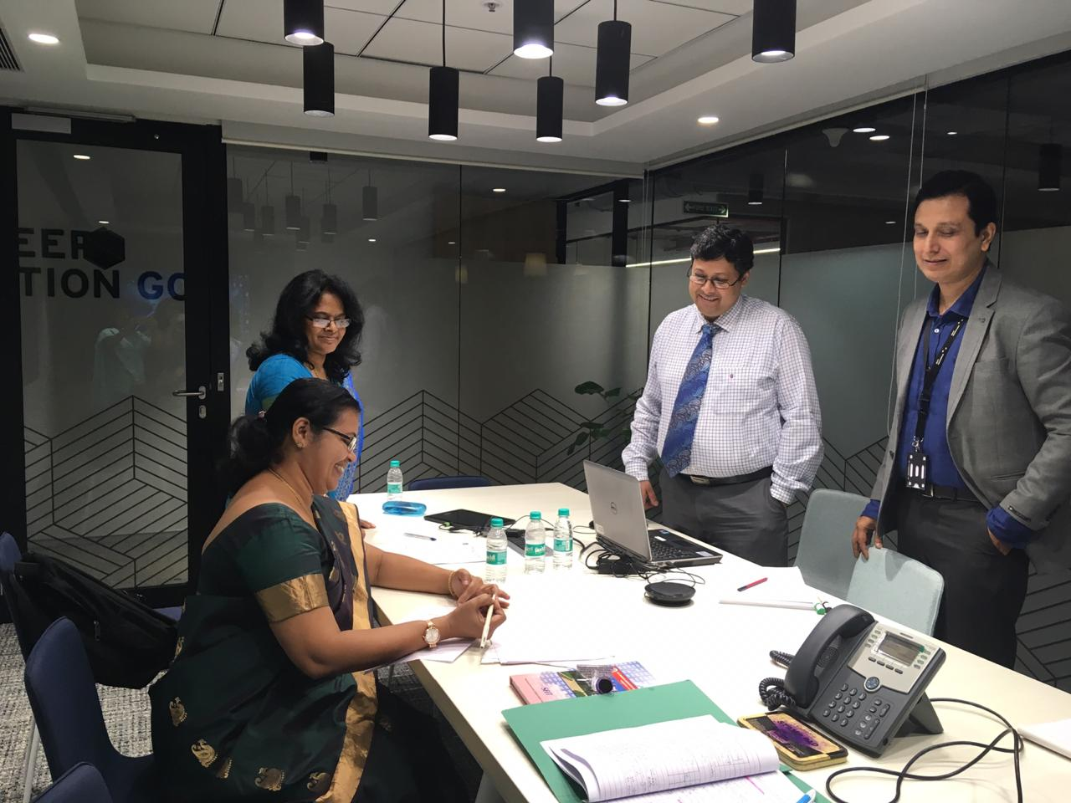
(L-R): Dr. Sincy George, Dr. Joanne Gomes, Mr. Amit Mukherjee, Mr. Ravindra Dwivedi

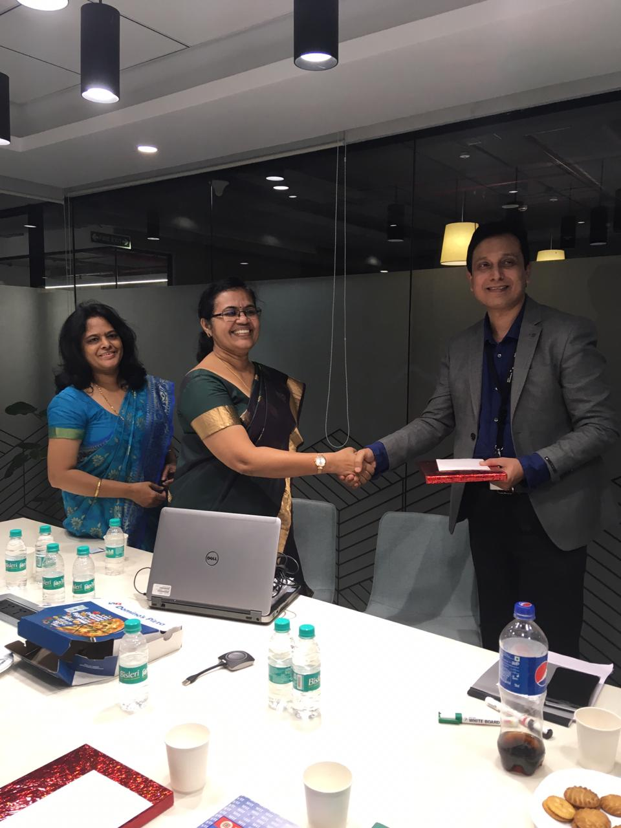
(L-R): Dr. Joanne Gomes, Dr. Sincy George, Mr. Ravindra Dwivedi

